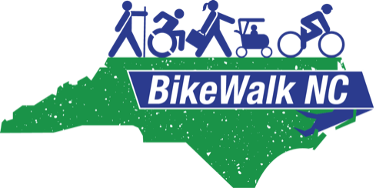

BikeWalkNC.org
Board Member Candidate Application

Thank you for your interest in joining BikeWalk NC, the state’s only nonprofit advocacy group for biking and walking. If you haven't already looked at our website, you can visit it at bikewalknc.org. It has a lot of information under our Safety and Education page, plus a page for our annual Summit and other information.

The Board of BikeWalk NC is a volunteer board with a paid Executive Director. We generally meet once a month by phone (currently on the 3rd Weds. of the month at 7:00 pm). In addition, we try to have representation in areas around the state by members in those areas. We have a Lobby Day in the Spring, a BikeWalk Summit in the fall, and a retreat once a year, usually in February. In addition, we have positions for members to help with finances, IT help, grant writing, fundraising and membership. We ask board members to be willing to put in between 4 and 8 hours a month in volunteer roles. These are 2-year terms, but are eligible for up to seven consecutive terms. In order to help us learn more about you and your interest in being a member of our Board, please fill out the form below and return it to director@bikewalknc.org.

Today's Date :

Your Name:
(First, Last, and name you prefer to be called if different from first name.)

Residence:
(Street address, City, Zip)

Phone:
E-mail:

Your Employer’s Name:
Employer Address:
Your title:
Type of business or organization:

Please list other boards and committees that you serve on, or have served on (business, civic, community, fraternal, political, professional, recreational, religious, social).

Organization Role/Title Dates of Service

1.
2.
3.
4.

Education/Training/Certificates that might be relevant?

Optional – Anything else you would like us to know?

What interests you about serving on the Board of BikeWalk NC?

Skills, experience and interests (Please check all that apply)

__Finance, accounting
__Website maintenance, IT support
__Nonprofit experience
__Community service
__Policy development
__Program evaluation
__Public relations, communications
__Education, instruction
__Special events
__Grant writing
__Fundraising
__Outreach, advocacy
Other:

Thank you again for your interest in serving on the Board of BikeWalkNC! We look forward to receiving your application and talking to you further. Please return this form to our director at
director@bikewalknc.org

