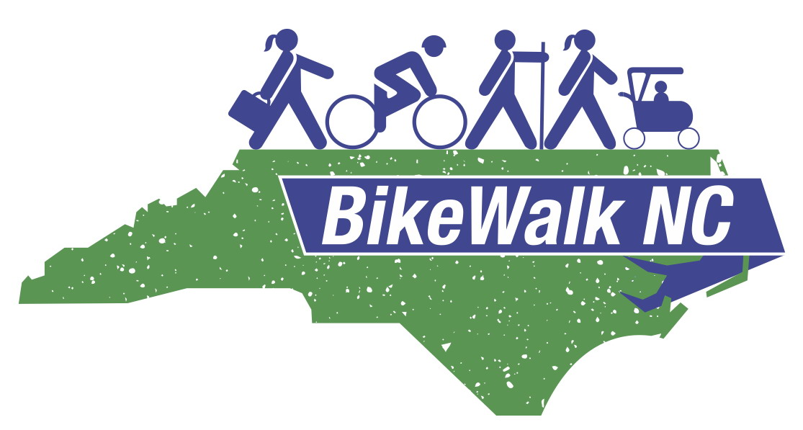

URGE REMOVAL OF ROAD DIET PROHIBITION
SECTION 7 OF HOUSE BILL 44

Section 7 of House Bill 44 was part of a 14-page addition by the Senate to a one paragraph House bill. The road diet restriction conditions of this bill are strictly based on traffic flow (called Level of Service) and don’t allow for consideration of other issues such as safety and economic development.

- The provision is overly prescriptive and may in effect reduce a community’s ability to optimize safety and congestion relief in a comprehensive manner.

- Each year 960 bicyclists are hit by vehicles in North Carolina (NC), making NC one of the least safe states in the US for bicycling. On average, about 160 pedestrians and 20 bicyclists are killed each year in the state, representing about 12% of all fatalities that occur on NC roads. African-Americans are disproportionately over represented in this unfortunate statistic.

- Pedestrian safety (and economic development) can be more important than maximizing vehicle throughput on some streets, especially “destination” streets such as Hillsborough Street in Raleigh and College Street in Asheville.

- Level of Service should not be the only criteria for evaluating road diets according to the Federal Highway Administration. Road diets are proven safety improvements for pedestrians and vehicle operators and are an essential tool to preserve for special locations.

- DOT division level engineers currently are involved with and must approve road diets – they are involved with the evaluation of volumes of traffic to insure that the roadway's level of service will not be compromised by a proposed road modification and have measures in place to mitigate any negative impact of any approved change.

- Local and state engineers should retain the discretion to plan and engineer reduced roadway cross sections to meet requirements other than maximizing traffic throughput and speed on a given corridor as part of their comprehensive planning processes.

